Team lead
221787@students.au.edu.pk
Abstract
This is the report for our project for the course Data Structure & Algorithms
Team project-DSA
Documentation



Instructor:
Mr. Muhammad Adnan Aslam

GROUP MEMBERS:

“ARKANOID GAME”

Syed Muhammad Taha | 221787
Darman Khan | 221853
Farhan Abdullah | 221813

Table of Contents:
GROUP MEMBERS: 1
Abstract: 3
1. Project Title: 3
2. Technologies Used: 4
3. Introduction: 5
4. Objectives: 5
5. Why we choose this Game? 7
6. Scope of Game: 8
6.1 Features & Functionalities: 8
7. Screenshots: 11

Abstract:
The short introduction of the project is discussed below:

The Arkanoid game, developed using SFML (Simple and Fast Multimedia Library) and C++, is a modern adaptation of the classic arcade game that challenges players with dynamic ball and paddle interactions. This project aims to showcase proficiency in game development, leveraging SFML's robust graphics capabilities and the principles of Data Structures and Algorithms. The game features a player-controlled paddle tasked with deflecting a ball to destroy a grid of blocks, each with unique properties. The proposal details the implementation of essential game components, including the ball, paddle, blocks, scoring system, and collision detection. Through this project, the integration of game design, programming, and algorithmic thinking is demonstrated, highlighting the potential for educational and entertainment purposes.

Project Title:

ARKANOID

Technologies Used:
- Type: Game Development
- Genre: Arkanoid-style Game
- Framework/Library: Simple and Fast Multimedia Library (SFML)
- Language: C++
- Technologies Used:
SFML (Simple and Fast Multimedia Library):
Handles graphics, window creation, and input management.
Provides classes and functions for 2D game development.
- Game Components:
- Sprites
- Textures
- Rendering
- Game Logic
- Event Handling
- Data Structure
- Randomization

Introduction:
The Arkanoid game, presented in this proposal, is an exciting and engaging project that combines the power of C++ programming, the SFML (Simple and Fast Multimedia Library) framework, and fundamental principles of data structures and algorithms. Arkanoid, a classic block-breaking arcade game, serves as the inspiration for this development endeavor. The goal of the game is to break through a wall of colored blocks using a bouncing ball controlled by a player-manipulated paddle. The fusion of technology and gaming nostalgia offers an enriching development experience while showcasing the application of data structures and algorithms in game design. This proposal outlines the objectives, design considerations, and technical aspects of the Arkanoid game, highlighting its potential for educational and recreational purposes.

4. Objectives:
- Develop a Classic Arkanoid Game:
Create a classic Arkanoid game with a paddle, bouncing ball, and destructible blocks.
- Implement Smooth Gameplay:

Ensure smooth and responsive gameplay by optimizing the game loop and user controls.
- Intuitive User Interface:
Design an intuitive and user-friendly interface, including a scoring system, to enhance the overall gaming experience.
- Dynamic Ball and Paddle Physics:
Implement dynamic ball and paddle physics to provide a realistic and engaging gaming environment.
- Collision Detection:
Implement accurate collision detection algorithms to ensure precise interactions between the ball, paddle, and blocks.
- Visual and Audio Enhancements:
Enhance the gaming experience with appealing graphics, animations, and sound effects to captivate players.
- Game Over Condition:
Implement clear game over conditions when the ball touches the ground or the blocks get destroyed.
- User Input Handling:
Efficiently handle user input for paddle movement, providing a seamless and enjoyable control experience.
- Responsive Game Controls:
Ensure that the game controls respond promptly to player input, contributing to a satisfying and immersive gaming experience.
- Bug-Free Gameplay:
Conduct thorough testing to identify and fix any bugs or glitches, ensuring a polished and stable game.
- Learning and Skill Development:
Use the project as an opportunity to enhance programming skills in C++, game development concepts, and familiarity with the SFML library.

5. Why we choose this Game?
As a group we choose Arkanoid to create because of certain factors which include:
- Classic Appeal:
Arkanoid is a classic and timeless arcade game that has captivated players for decades. It’s simple yet addictive gameplay has stood the test of time, making it an ideal choice for a development project.
- Educational Value:
The development of Arkanoid provides an opportunity to reinforce and apply key concepts in data structures and algorithms. The game involves collision detection, dynamic ball movement, and scoring systems, allowing for a hands-on exploration of fundamental programming principles.
- Skill Development:
Developing this game provides an avenue for honing programming skills while creating an enjoyable and challenging gaming experience.
- SFML Framework:
Choosing Arkanoid allows for the utilization of the SFML framework, a powerful and user-friendly multimedia library for C++.
- Balanced Complexity:
Arkanoid strikes a balance between complexity and simplicity, making it an ideal choice for a student project.
- Recreational Enjoyment:
Beyond its educational aspects, Arkanoid promises to deliver an entertaining and nostalgic gaming experience.

6. Scope of Game:

6.1 Features & Functionalities:
- Game Elements:
- Paddle: Controlled by the player to bounce the ball.
- Ball: Moves around the game area, bouncing off the paddle and blocks.
- Blocks: Arranged in a grid, and the player's goal is to destroy them by hitting them with the ball.
- Background: A static background image.
- Game Mechanics:
- The player can control the paddle using the arrow keys (Right and Left).
- When the ball hits the paddle, it changes its vertical direction randomly, simulating a more dynamic bounce.
- The game detects collisions between the ball and blocks, updating the score when a block is destroyed.
- The game ends when the ball touches the ground (y > 450) or all the blocks are destroyed.
- Scoring System:
- Each block hit contributes to the player's score.
- The score is displayed on the top-left corner of the window.
- Game over Conditions:
The game ends when the ball touches the ground, and a "Game Over" event is triggered or when all the blocks are destroyed, closing the application.

- User Interaction:
The player interacts with the game using keyboard inputs to move the paddle.
- Technical Aspects:
The game utilizes the SFML library for graphics and events handling.
Randomization is used for the vertical direction change of the ball when it hits the paddle.
- Scope Limitations:
The game is relatively simple, lacking advanced features like power-ups, different block types, or levels.
Graphics and animations are basic, serving a functional purpose. The code structure could be improved for better maintainability and readability.

7. Screenshots:

Code:

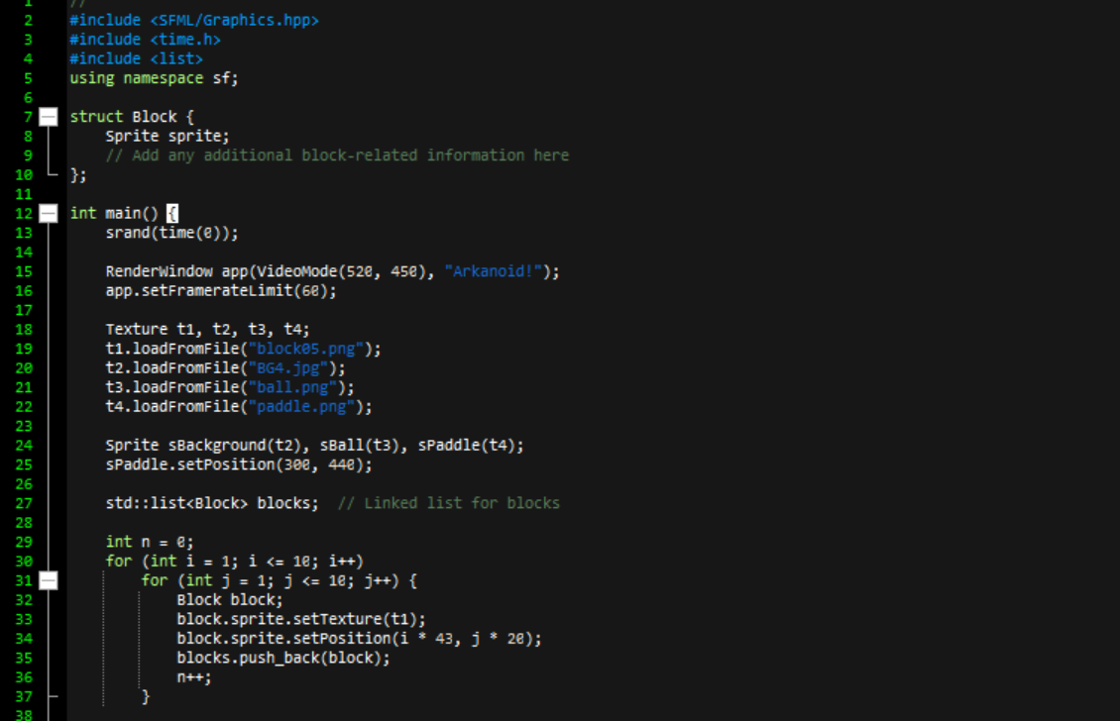
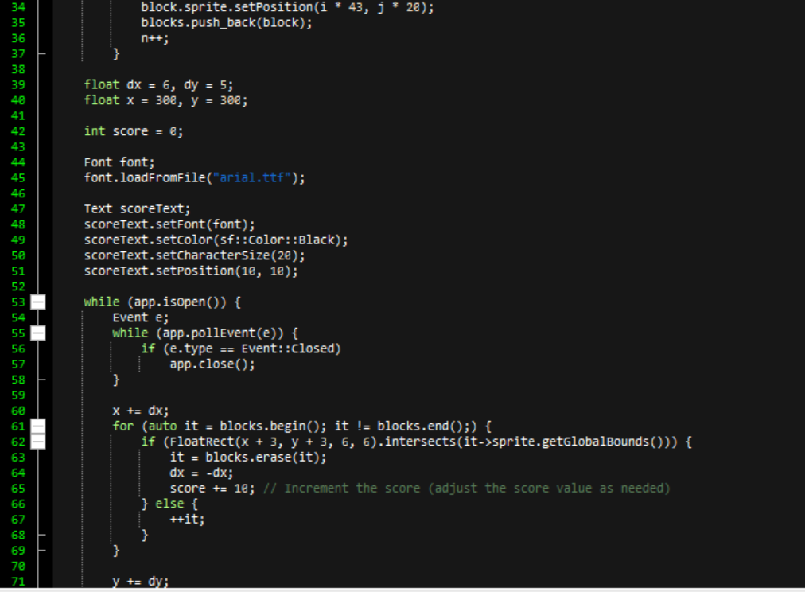
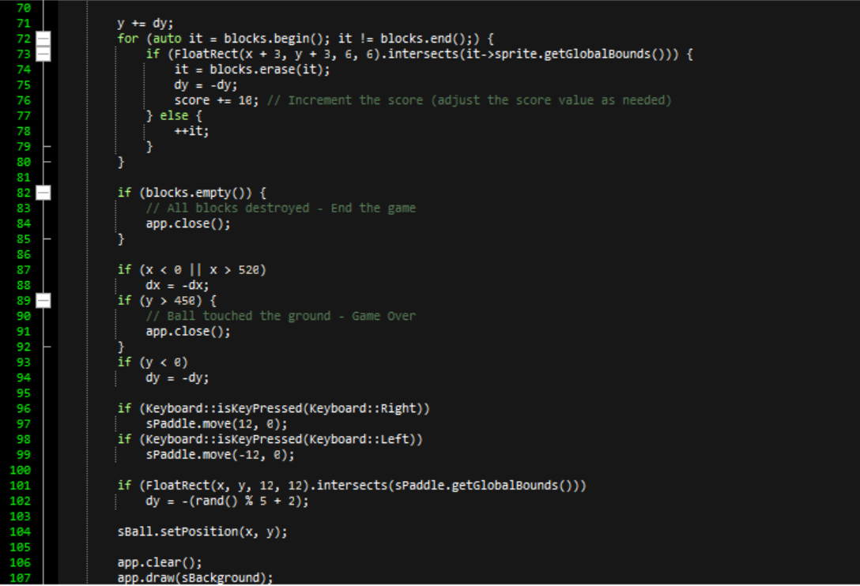
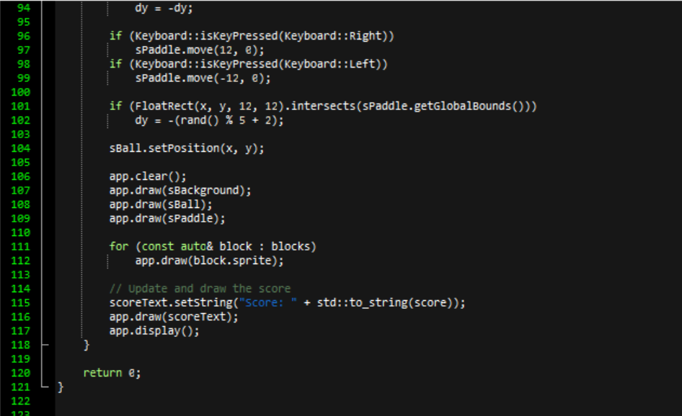
Output:

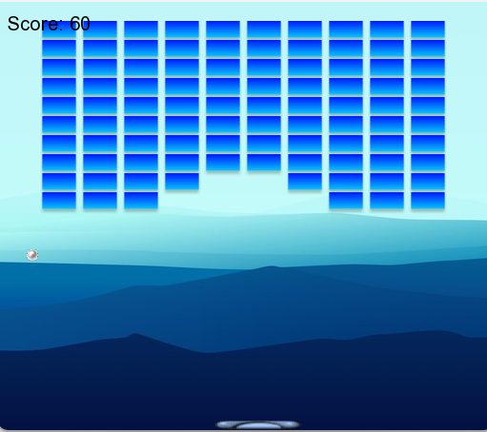

THE END🙂

